|  |  |
| --- | --- |
| **Logo - Club Logo copy**  Breakfast Chatter  2016/2017 | C:\Users\arasmussen\Pictures\New folder\Rotary.png |

##### The Weekly Bulletin of Rotary Club of Kathmandu Mid-Town Celebrating 27 Years of Rotary

### September is Basic Education and Literacy Month

# Weekly Meetings and Programmes:

|  |  |  |
| --- | --- | --- |
| **Date** | **Speaker** | **Program/Topics of Presentation** |
| 9 September | Bev Hoffman | Bev Hoffman is the Director of Human Rights Film Focus Nepal, and the Coordinator of HRFFN's Wall of Hope initiative, an education, advocacy, and awareness campaign to stop violence against women and girls.   The Campaign has directly impacted over 20,000 students in Nepal from over 250 schools. The Global Wall of Hope Campaign was launched at the International Rotary Peace Conference that took place in southern California last January.  Induction of new Member, Dr. Dale Mole |
| 2 September | In-house Speaker **Rtn. Dr. Rup Khadka** | ‘Federal Fiscal System’.  From Dr. Khadka’s CV:  I am an expert in the development and implementation of tax policy, tax legislation, tax administration and inter-governmental fiscal relations. I have over 25 years of experience in VAT, income tax, excise duties, customs duties, property taxes, inter-governmental fiscal relation, tax laws, tax regulations, tax procedures, tax administration ( including merger of VAT and income tax administrations, establishment of large taxpayer office, design and implementation of functional structure), capacity building, and taxpayer education. I have published many articles in national/international journals and published several books. I have prepared many reports/papers, including Harvard University’s HIID/ITP Discussion Papers/Working Papers. I have delivered lectures on VAT at the Tribhuvan University Nepal, National Institute of Public Finance and Policy India, Harvard University USA and Slavanic University Tajikistan.  Dr. Khadka is a new member of the club. |
| Club News | | |

|  |  |  |  |
| --- | --- | --- | --- |
| Rtn. Dr. Rup Khadka gave a fascinating presentation on Nepal’s Federal Fiscal System.  His presentation was followed by many questions which he could not answer due to lack of time and he has promised to address these next Friday.  Rtn. Prasun Jalan gave the vote of thanks. President Shankar handed over the token of appreciations after the presentation  There will be no ordinary meeting on September 16, instead we will together with our families and friends do an outing on Chandragiri. More information to come during our next meeting.  C:\Users\arasmussen\AppData\Local\Microsoft\Windows\INetCache\Content.Outlook\CBTFF60Q\IMG_1453.JPGC:\Users\arasmussen\AppData\Local\Microsoft\Windows\INetCache\Content.Outlook\CBTFF60Q\IMG_1442.JPG | | C:\Users\arasmussen\AppData\Local\Microsoft\Windows\INetCache\Content.Outlook\CBTFF60Q\IMG_1448.JPG Other News We are delighted to invite you and members of your institution to a book discussion program.  Please find the details below:  **Date:  Sunday, September 25, 2016**  **Time:  3:00PM**  **Venue:  Dwarika’s Hotel**  The theme of the talk program is, “The Ethical Self and Business Ethics". This book was recently published and launched in Nepal ​​ through the World Forum Ethics in Business Nepal and the Art of Living Foundation.    ​An Open Discussion with a Panel will be included to help facilitate the topic further.   The discussion stems from the need to reconsider business ethics styles and strategies in the face of the ongoing social and economic challenges in Nepal.  Many prominent individuals were​  interviewed for the book and provided their valuable input. | The book includes examples of ethical practices that are sustainable and ensure profitability for institutions. We would like to take this opportunity to provide a platform for leading minds to share their experiences on the value​s and challenges​  of an ethics based approach ​in running any organisation. ​  F​or the first time in Nepal, 28 colleges will be offering BBA program under Tribhuwan University later this year.  The academic circle could benefit from valuable examples from institutions to be aware of best practices.  World Forum for Ethics in Business Nepal in 2014, brought together prominent leaders from the areas of business, politics, academia, youth, civil society and faith‐based organizations, for a dialogue on the pressing need of strengthening human values and ethics in business and in leadership.  W​e are grateful to Ms. Ambica Shrestha and Dwarika's Hotel for their support in hosting the event.  We look forward to your participation.  ​​Will appreciate confirmation (and how many from your team plan to attend) by Monday, September 12.  Warm wishes,  N​eeva M. Pradhan, 9851233348​ |
|  |  | | | |

|  |
| --- |
| Rotary Story of the Week |

|  |  |  |
| --- | --- | --- |
| HALL OF FAME SINGER DONOVAN BECOMES A ROTARY POLIO AMBASSADOR Legendary singer and polio survivor Donovan Leitch, better known simply as Donovan, has joined Rotary in its fight to eradicate the paralyzing disease that afflicted him during much of his childhood.  Donovan contracted polio at age three in Glasgow, Scotland. The disease weakened his right leg and left it thinner and shorter than the other. Confined to his bed for much of his childhood, the Rock and Roll Hall of Fame singer said his father would read him poetry.  In a recent [interview with the Daily Express](http://www.express.co.uk/life-style/health/695432/Dovovan-Leitch-folk-singer-childhood-polio-musician), Donovan said that listening to poetry piqued his interest in creative writing. “If I hadn’t had that experience maybe I wouldn’t have gone on to write and sing my own songs for the past half a century.  “I feel strongly that having a disability in one area makes you explore others instead. That was the case for me after having polio,” says Donovan, who recently became a Rotary polio ambassador.  Donovan went on to record several hit albums and singles in the UK, United States, and other countries. His top singles include “Mellow Yellow” and “Hurdy Gurdy Man.” Donovan collaborated with The Beatles on songs including “Yellow Submarine” and has shared the stage with musical icons Bob Dylan and Joan Baez.  “Having had polio never held me back as I got older. Although having one leg smaller than the other isn’t much fun I could always get about without any trouble,” Donovan says. “Luckily in the music industry everyone was only interested in my singing and playing and not the size of my legs.”  As a Rotary polio ambassador, Donovan will support the [Purple4Polio campaign](http://www.rotarygbi.org/what-we-do/purple4polio/), a collaboration between Rotary International in Great Britain and Ireland and the Royal Horticultural Society. The purple represents the colored dye that health workers use during immunization campaigns to mark the fingers of children who have received the polio vaccine.  “It was very easy to join this campaign because I had polio, and I wanted to tell everybody that it’s almost eradicated around the world,” Donovan says. “This is very important. I want to help with that last push, which is always the hardest. ”  [Give to End Polio Now](http://www.endpolio.org/donate) |  |  |
|  |  |  |

# Rotary International News

#### CHARITY NAVIGATOR UPGRADES ROTARY FOUNDATION’S RATING

The Rotary Foundation has received the highest possible score from [Charity Navigator](https://www.charitynavigator.org/index.cfm?bay=search.summary&orgid=4553), an independent evaluator of charities in the U.S.

In the most recent ratings, released on 1 September, The Rotary Foundation earned the maximum 100 points for both financial health and accountability and transparency.

The ratings reflect how efficiently Charity Navigator believes the Foundation will use donations, how well it has sustained programs and services, and its level of commitment to good governance and openness.

In the previous rating, the Foundation had received 97 points.otary Calendar

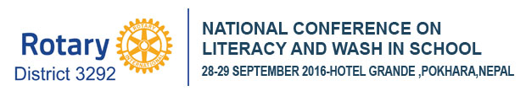

1 October — Deadline to submit nominations for the [Rotary Service Above Self Award](https://www.rotary.org/myrotary/en/learning-reference/learn-topic/awards)

24 October — [Rotary's World Polio Day Livestream Event](http://www.endpolio.org/worldpolioday)

31 October-6 November — World Interact Week

1 November — [Service Award for a Polio-Free World](https://www.rotary.org/myrotary/en/learning-reference/learn-topic/awards) nominations are due

### Please update your ‘My Rotary’ Account

First go to www.rotary.org.

Then **click on My Rotary**. And then **Click on Sign In/Register**.

If you are a first time user, click on **Create account.**

Fill in the Account registration information **and click on Continue.**

You will be informed that an e-mail has been sent to you.

Check your email for the address you provided in the step above. You will receive a message from Rotary. Click on the blue link in the mail to finalize the process.

# A Thought for the Day:

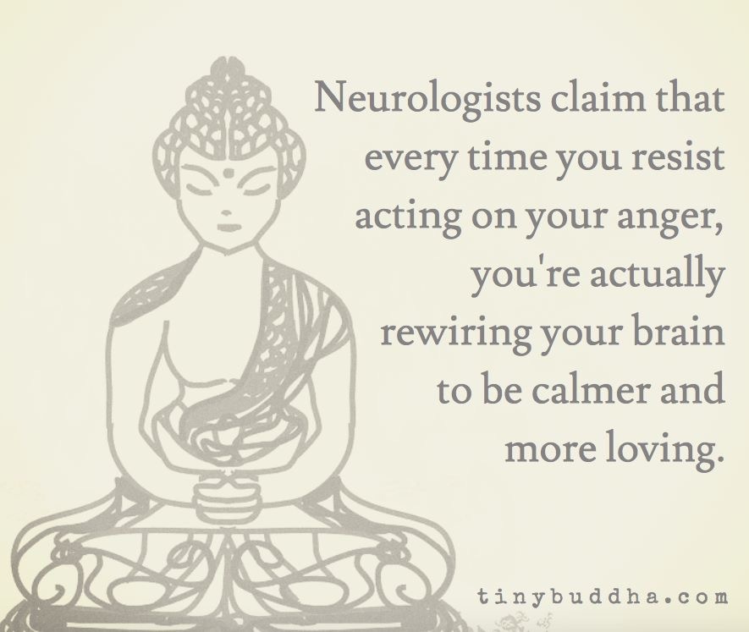

### Nepali holidays in September

|  |  |  |  |  |  |
| --- | --- | --- | --- | --- | --- |
| |  |  |  | | --- | --- | --- | | 20 | Sep | [Constitution Day](http://publicholidays.asia/nepal/constitution-day/)  Constitution Day in Nepal was, in earlier years, held on November 9th to commemorate the 1990 constitution, but in 2015, a new constitution was enacted on September 20th, with the date of celebrations correspondingly being moved. |   **Indra Jātrā** as it is most commonly known or **Yenyā** (Nepal Bhasa: येँयाः) is the biggest religious street festival in Kathmandu. Yenya means "Kathmandu festival" in Nepal Bhasa. The celebrations consist of two events.  **Indra Jātrā** is marked by masked dances of deities and demons, displays of sacred images and tableaus in honor of the deity Indra, the king of heaven. The other event is **Kumāri Jātrā**, the chariot procession of the living goddess Kumari.  Family members deceased in the past year are also remembered during the festival. The main venue of the festivities is Kathmandu Durbar Square. The celebrations last for eight days from the 12th day of the bright fortnight to the 4th day of the dark fortnight of Yanlā (ञला), the eleventh month in the lunar Nepal Era calendar.  Indra Jatra was started by king Gunakamadeva to commemorate the founding of the city of Kathmandu in the 10th century.[[3]](https://en.wikipedia.org/wiki/Yenya#cite_note-GP1-3) Kumari Jatra began in the mid-18th century. The celebrations are held according to the lunar calendar, so the dates are changeable. The 2016 date is September 27.  The festival starts with **Yosin Thanegu** (योसिं थनेगु), the erection of Yosin or Linga, a pole from which the banner of Indra is unfurled, at Kathmandu Durbar Square. The pole, a tree shorn of its branches and stripped of its bark, is obtained from a forest near [Nālā](https://en.wikipedia.org/wiki/Nala,_Nepal" \o "Nala, Nepal), a small town 29 km to the east of Kathmandu. It is dragged in stages to Durbar Square by men pulling on ropes.  Another event on the first day is **Upāku Wanegu** (उपाकु वनेगु) when participants visit shrines holding lighted incense to honor deceased family members. They also place small butter lamps on the way. Some sing hymns as they make the tour. The circuitous route winds along the periphery of the historic part of the city. |  |  |
|  |  |  |

NB: Send any information/photos that may be of interest to the Club or Rotarians in general to

BC Editor: Anja M. Rasmussen, email: anjamrasmussen@gmail.com

District : 3292 Web: www.rotarymidtown.org.np Club Id : 26776

Facebook: <https://www.facebook.com/RotaryClubOfKathmanduMidtown>

Venue: Fridays at 7:30AM, Hotel de l'Annapurna, Kathmandu, NEPAL

Thanks to Isabell Khadka for a thought for today